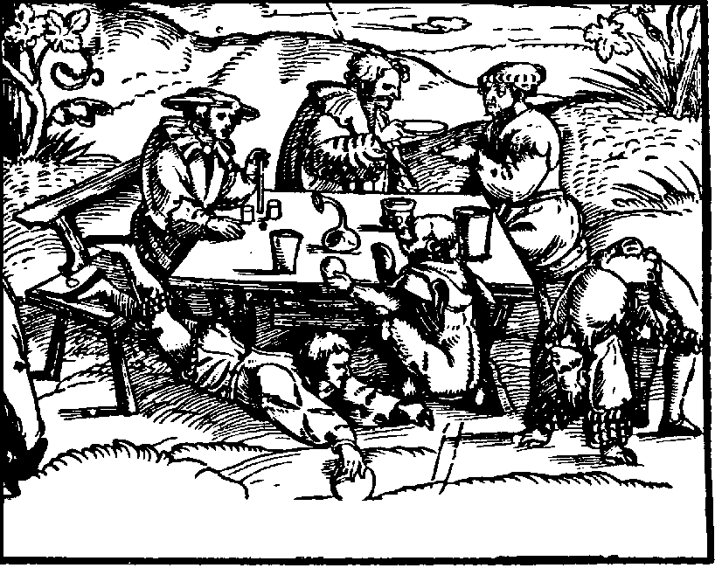
New Year’s Brew John Smith 1999-2000
New Year’s Brew John Smith 1999-2000
New Year’s Brew John Smith 1999-2000
New Year’s Brew John Smith 1999-2000
New Year’s Brew John Smith 1999-2000
New Year’s Brew John Smith 1999-2000
Label copyright (c) 2004 Joyce C. Hersh
Label copyright (c) 2004 Joyce C. Hersh
Label copyright (c) 2004 Joyce C. Hersh
Label copyright (c) 2004 Joyce C. Hersh
Label copyright (c) 2004 Joyce C. Hersh
Label copyright (c) 2004 Joyce C. Hersh

